**Courier Management System**

**RollNo: 1918**

***ABSTRACT***

In this project I created a website which is easy to access user friendly. For this Website i used the backend as MySQL Server (Xampp) to store the data which is used in the Website and for the user interface we had used the HTML/CSS/JavaScript.

Four kinds of people /Users are able to use this website as a Admin, Manager who manage the data (Staff /Delivery person) and the customer as well. The customer is able to do the online Tracking Shipment and more features very easily. The Staff is the only person who is able to book the shipment from the site. The delivery person is able to update the delivery status and the main super user (Admin) can allow the user permission, who can assess the particular interface (like i created three interfaces for admin, staff and for the customer).

***Scope of Project***

The scope of the project is clear to give a simple and attractive website to simplify the work as well as to reduce the efforts while doing it offline or we can say by doing it with old methods.

In this website we are able to save a huge database very easily and access it from anywhere.

**System Requirements**

We are going to perform the project on windows platform so we need the os as windows. Any version of windows as windows xp, windows 7or windows 8. The system should have minimum ram of 4gb as well as minimum storage capacity of 250gb.The system should contain the server software named as “Python Django Webserver”. And “MySQL DB” using Xampp software. we have to install both software and we have to do connectivity between them by changing the configuration file of “.py”.

**DATA DIRICTORY**

**Table name: -**

**User Login**

|  |  |  |  |  |
| --- | --- | --- | --- | --- |
| **SELECT * FROM AUTH_USER** | | | | |
| # | NAME | NULL? | TYPE | EXTRA |
| 1 | ID | NOT NULL | INT(11) | AUTO INCREMENT |
| 2 | PASSWORD | NOT NULL | VARCHAR(128) |  |
| 3 | LAST_LOGIN | NULL | DATETIME(6) |  |
| 4 | IS_SUPERUSER | NOT NULL | TINYINT(1) | 0 OR 1 |
| 5 | USERNAME | NOT NULL | VARCHAR(150) |  |
| 6 | FIRST_NAME | NOT NULL | VARCHAR(150) |  |
| 7 | LAST_NAME | NOT NULL | VARCHAR(150) |  |
| 8 | EMAIL | NOT NULL | VARCHAR254) |  |
| 9 | IS_STAFF | NOT NULL | TINYINT(1) | 0 OR 1 |
| 10 | IS ACTIVE | NOT NULL | TINYINT(1) | 0 OR 1 |
| 11 | DATE_JOINED | NOT NULL | DATETIME(6) |  |

|  |  |  |
| --- | --- | --- |
| SELECT * FROM AUTH_GROUP | | |
| # | ID | NAME |
| 1 | 2 | ADMIN |
| 2 | 1 | STAFF |

|  |  |  |  |  |
| --- | --- | --- | --- | --- |
| **SELECT * FROM AUTH_USER_GROUPS** | | | | |
| # | NAME | NULL? | TYPE | EXTRA |
| 1 | ID | NOT NULL | INT(11) | AUTO INCREMENT |
| 2 | USER_ID | NOT NULL | INT(11) | FK |
| 3 | GROUP_ID | NULL | INT(11) | FK |

auth_user_groups_group_id_97559544_fk_auth_group_id

auth_user_groups_user_id_6a12ed8b_fk_auth_user_id

|  |  |  |
| --- | --- | --- |
| SELECT * FROM AUTH_GROUP | | |
| # | ID | NAME |
| 1 | 2 | ADMIN |
| 2 | 1 | STAFF |

|  |  |  |  |  |
| --- | --- | --- | --- | --- |
| **SELECT * FROM `AUTH_GROUP_PERMISSIONS** | | | | |
| # | NAME | NULL? | TYPE | EXTRA |
| 1 | ID | NOT NULL | int(11) | AUTO INCREMENT |
| 2 | GROUP_ID | NOT NULL | int(11) | FK |
| 3 | PERMISSION_ID | NOT NULL | int(11) | FK |

auth_group_permissio_permission_id_84c5c92e_fk_auth_permission

auth_group_permissions_group_id_b120cbf9_fk_auth_group_id

|  |  |  |  |  |
| --- | --- | --- | --- | --- |
| **SELECT * FROM AUTH_PERMISSION** | | | | |
| # | NAME | NULL? | TYPE | EXTRA |
| 1 | ID | NOT NULL | INT(11) | AUTO INCREMENT |
| 2 | NAME | NOT NULL | VARCHAR(255) | |
| 3 | CONTENT_TYPE_ID | NOT NULL | INT(11) |  |

auth_permission_content_type_id_2f476e4b_fk_django_content_type

|  |  |  |  |  |
| --- | --- | --- | --- | --- |
| **SELECT * FROM DJANGO_CONTENT_TYPE** | | | | |
| # | NAME | NULL? | TYPE | EXTRA |
| 1 | ID | NOT NULL | INT(11) | AUTO INCREMENT |
| 2 | APP_LABEL | NOT NULL | VARCHAR(100) | |
| 3 | MODEL | NOT NULL | VARCHAR(100) | |

|  |  |  |  |  |
| --- | --- | --- | --- | --- |
| **SELECT * FROM DJANGO_CONTENT_TYPE** | | | | |
| # | NAME | NULL? | TYPE | EXTRA |
| 1 | ID | NOT NULL | INT(11) | AUTO INCREMENT |
| 2 | AWB | NOT NULL | INT(11) | UNIQUE |
| 3 | SFNAME | NOT NULL | VARCHAR(20) |  |
| 4 | SLNAME | NOT NULL | VARCHAR(20) |  |
| 5 | STREETADD | NOT NULL | VARCHAR(30) |  |
| 6 | STREETADD2 | NOT NULL | VARCHAR(30) |  |
| 7 | SCITY | NOT NULL | VARCHAR(20) |  |
| 8 | SSTATE | NOT NULL | VARCHAR(20) |  |
| 9 | SCOUNTRY | NOT NULL | VARCHAR(20) |  |
| 10 | SPOSTAL | NOT NULL | INT(11) |  |
| 11 | SMOBILE | NOT NULL | INT(11) |  |
| 12 | RFNAME | NOT NULL | VARCHAR(20) |  |
| 13 | RLNAME | NOT NULL | VARCHAR(20) |  |
| 14 | RSTREETADD | NOT NULL | VARCHAR(30) |  |
| 15 | RSTREETADD2 | NOT NULL | VARCHAR(30) |  |
| 16 | RSCITY | NOT NULL | VARCHAR(20) |  |
| 17 | RSTATE | NOT NULL | VARCHAR(20) |  |
| 18 | RCOUNTRY | NOT NULL | VARCHAR(20) |  |
| 19 | RPOSTAL | NOT NULL | INT(11) |  |
| 20 | RMOBILE | NOT NULL | INT(11) |  |
| 21 | WEIGHT | NOT NULL | DOUBLE |  |
| 22 | SHIPTYPE | NOT NULL | VARCHAR(10) |  |
| 23 | COST | NOT NULL | DOUBLE |  |

**Existing system**:

There are many websites where user can search for places but not by preference or category.

**Proposed system:**

This system will allow users search for places by categories and filtered by their preferences. And also will be able to give feedback.

**Modules**:

1. LOGIN as admin /customer/staff manager (office staff/delivery person)
2. SIGNUP (staff can register for the staff member but login is depending on admin approval)
3. Public interface (customer dashboard home page no need to login)
4. Staff dashboard interface (Only staff /Admin member can login)
5. Tracking system (Available for all the user)
6. Shipment Rate Calculator (Available for all the user)
7. Pincode Search (using Pincode Searching either at that locality services are available are not , Available for all the user)
8. Search places
9. Add, delete, update, Set permission (Only Admin)
10. Logout

**Use Case Diagram (UML): may be some changes**

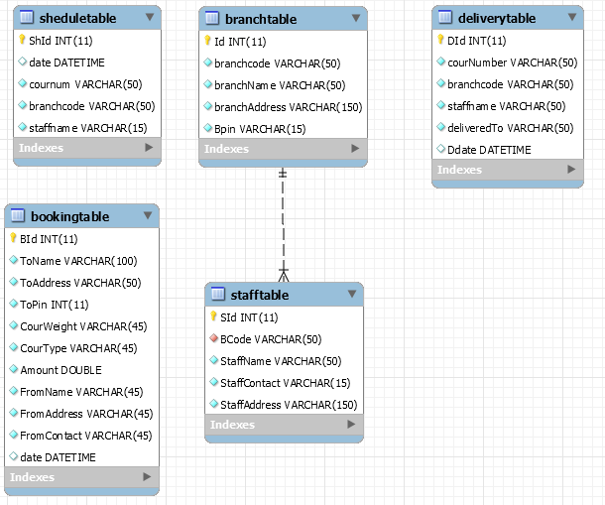

**ER Diagram**: may be some changes

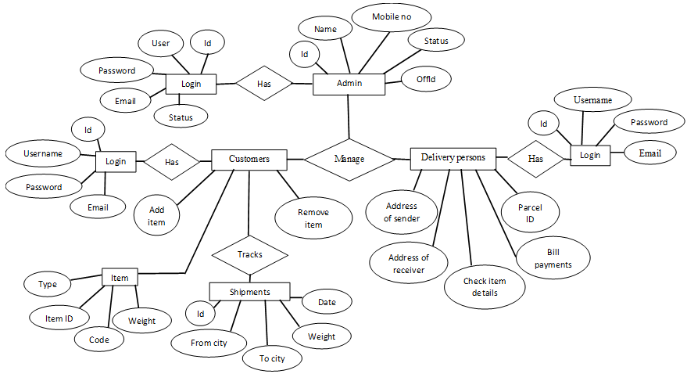

**Screenshots (mid project demo design of website may change later):**

Login Staff

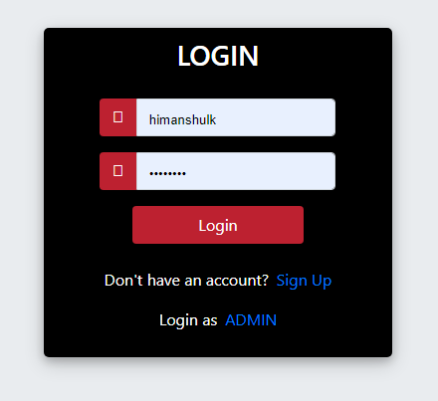

Login ADMIN

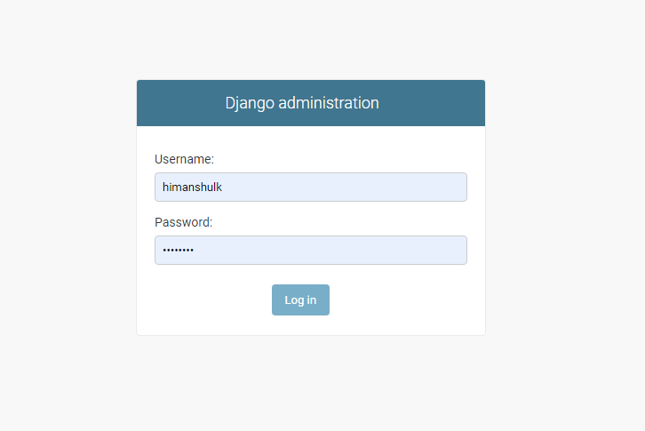

User interface

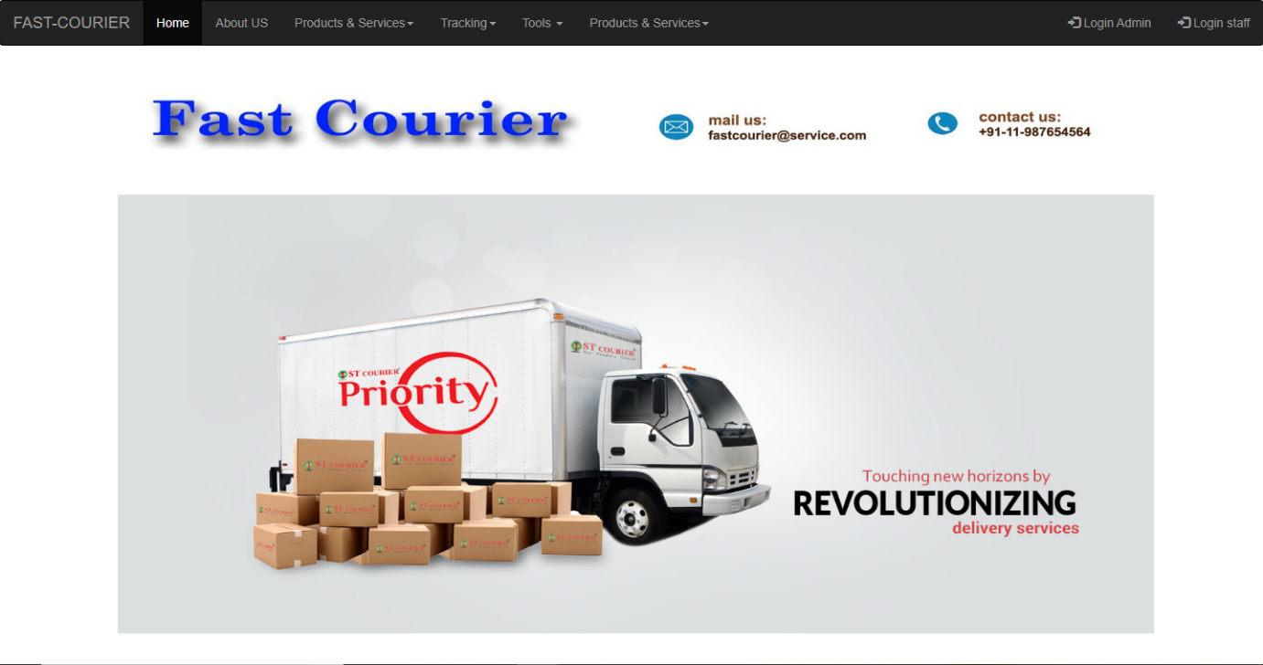

Admin interface

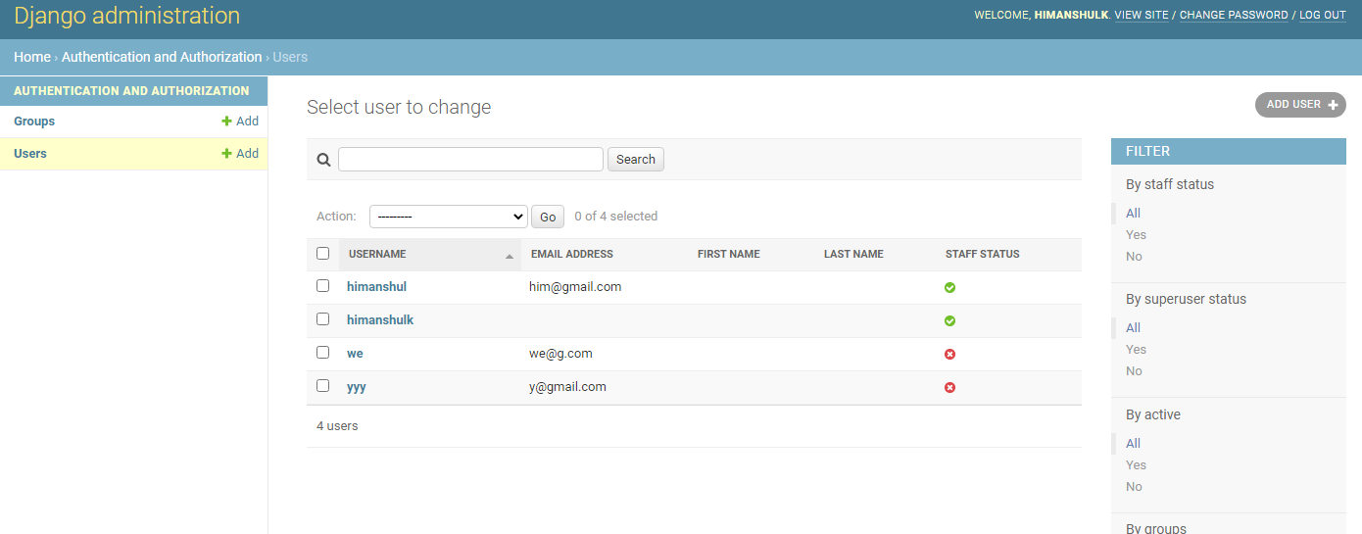

Staff Interface

